SUMMERLAND UNITED CHURCH
celebrating faith
seeking justice and
serving others in a loving community

A Joint Sunday Service for Summerland and Westbank United Churches
Rev. Paul James, Summerland United - Presiding
Sunday, April 25, 2021 * 10 a.m.

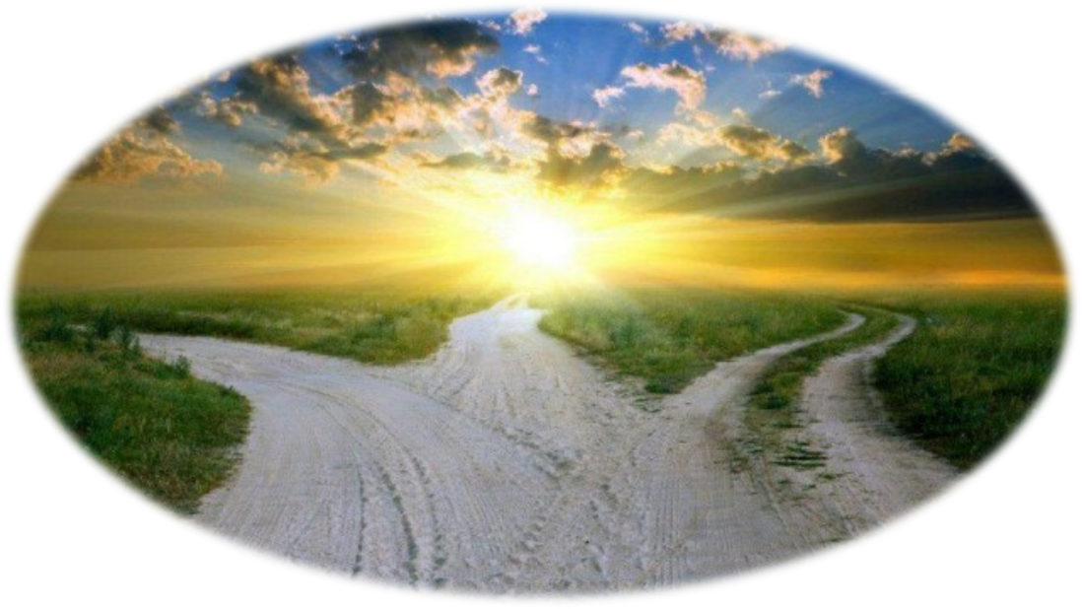

PowerPoint Creation: Judi Ritcey – Summerland United
Powerpoint Presenter: Only if other than Judi
Words of Welcome: Summerland United
Scripture Reading: Rev. Paul James

GATHERING TIME | 9:45AM
INTRODUCTION & EXPLANATION | Rev. Paul James
TERRITORIAL ACKNOWLEDGEMENT | Rev. Paul James

ANNOUNCEMENTS
BELL RINGING
WORDS OF WELCOME | Judy Nagus, Westbank United

A warm welcome to our friends from Summerland, Westbank, Osooyos United Church and Oliver United Churches who are with us today and to all those joining us from other locations. If there are any visitors today from other congregations or other places, we welcome you and thank you for joining us this morning. If you are comfortable, please unmute yourself and tell us where or what congregation you are from. Please remember to re-mute yourself.
MOMENT OF SILENCE TO VIEW THE CONGREGATION

Friends, we gather apart but together. I invite you now to switch to gallery view or scroll through your screen to witness the children of God gathered with us today.

LIGHTING THE CANDLE | Rev. Paul James

WE SING TOGETHER | All the Ends of the Earth – Rev. Bob Dufford

CALL TO WORSHIP

One: Bless the Lord, O my soul; and all that is within me,
bless God’s holy name!
All: Bless the Lord, O my soul, and forget not
all God’s benefits.
One: God is merciful and gracious, slow to anger
and abounding in steadfast love.
All: As the heavens are high above the earth
So great is God’s love toward us.
Bless the Lord, O my soul, and all that is within me
bless God’s holy name.

OPENING PRAYER
O God of life, there is much that deals in doubt and despair and death in our world, and we are often tempted to succumb to these forces. Help us always to choose life; to affirm what can be affirmed, to hope where hope is possible; and to risk ourselves to lift up human dignity.

SCRIPTURE READING | Acts 16: 1 – 15  Charlotte Burley, Summerland United

WE SING TOGETHER | VU #225 - We Praise You for the Sun
WORDS OF REFLECTION |  | “Failure to Fail”  Rev. Paul James
WE SING TOGETHER |  | VU #642 - Be Thou My Vision

PRAYERS OF THE PEOPLE | Rev. Paul James

THE LORD’S PRAYER - Traditional | Rev. Paul James

OFFERING | Rev. Paul James

PRAYER OF DEDICATION | Rev. Paul James

All we have is from you, O God. All that we enjoy is the rich bounty of your love poured out on us. In Christ, we have witnessed your care; in Christ, we have learned to share. In joy, we worship you with our gifts and present ourselves for your blessing. Send your Spirit once more to empower our service, in Christ’s name. Amen
WE SING TOGETHER | MV 82 - Bathe Me in Your Light

BLESSING | Rev. Paul James

BREAK INTO CHAT ROOMS

STORIES OF OUR MISSION: WHEN BEING BORN WITH LIGHT SKIN IS DANGEROUS
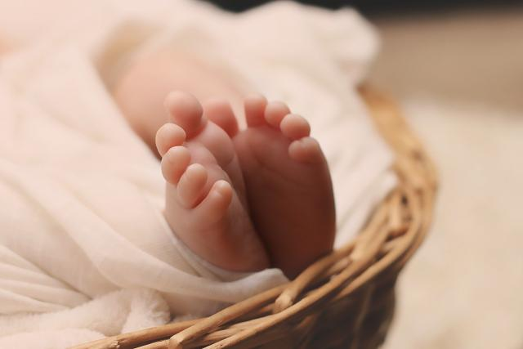
Being born with light skin is particularly dangerous in Tanzania where 1 in 1400 people have albinism. Few people in Tanzania with albinism live beyond the age of 40, and not just because of high rates of skin cancer. Because some Tanzanian belief systems portray people with albinism as magical, there is a lucrative trade in their body parts, which are believed to hold special power—and the pandemic has
Credit: Image by esudroff from Pixabay
made this situation even worse. That’s why your generosity through Mission & Service is helping the Morogoro Women’s Training Centre provide support to young Tanzanian women with albinism.
When Ikponwosa Ero, was five years old, she couldn’t walk down the street without being taunted for having albinism, a genetic condition that results in lack of pigmentation in skin, eyes, and hair. Children would taunt her with rude songs and pull her hair. When she told teachers, she couldn’t see well (a condition common for people with albinism), they accused her of lying.
Today, Ero, a lawyer, advocates for people with albinism. In 2015, the United Nations appointed her as the first Independent Expert on the subject. Ero’s priority is to end brutal attacks against people with albinism. More than 600 attacks have taken place in 26 African countries since 2007; two-thirds of the victims are children.
Being born with light skin is particularly dangerous in Tanzania, where 1 in 1,400 people have albinism. Few of these people live beyond the age of 40, not only because of high rates of cancer but also because of belief systems.
Some belief systems portray people with albinism as magical. As a result, there is a lucrative trade in their body parts, which are believed to hold special power.
The COVID-19 pandemic has made the situation even worse because people can’t get to medical appointments or purchase sunscreen. In some communities, people with albinism are blamed for the outbreak of the pandemic.
That’s why your generosity through Mission & Service is supporting the Morogoro Women’s Training Centre to host seminars for young Tanzanian women with albinism. Topics like disability rights, legal protection, and entrepreneurship will be covered.

