SUMMERLAND UNITED CHURCH
celebrating faith
seeking justice and
serving others in a loving community

A Joint Sunday Service for Summerland and Westbank United Churches
Rev. Donald Schmidt - Presiding
Sunday, May 9th, 2021 – 10 a.m.

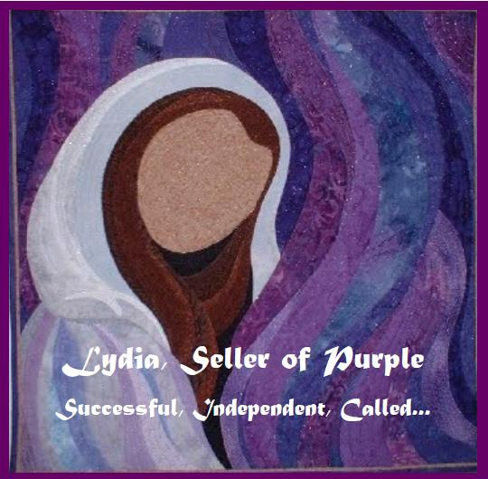

PowerPoint Creation: Judi Ritcey – Summerland United
Words of Welcome: - Ken Bridges, Westbank United
Scripture Reading: - Linnea Good, Summerland United

GATHERING TIME | 9:45AM
INTRODUCTION & EXPLANATION | Rev. Donald Schmidt
TERRITORIAL ACKNOWLEDGEMENT | Rev. Donald Schmidt

ANNOUNCEMENTS
BELL RINGING
WORDS OF WELCOME | Ken Bridges, Westbank United
A warm welcome to our friends from Summerland and Westbank United Churches who are with us today and to all those joining us from other congregations and locations. If there are any visitors today from other congregations or other places, we welcome you and thank you for joining us this morning. If you are comfortable, please unmute yourself and tell us where or what congregation you are from. Please remember to re-mute yourself.
MOMENT OF SILENCE TO VIEW THE CONGREGATION
Friends, we gather apart but together. I invite you now to switch to gallery view or scroll through your screen to witness the children of God gathered with us today.

LIGHTING THE CANDLE | Rev. Donald Schmidt
WE SING TOGETHER | MV 145 – Draw the Circle Wide

CALL TO WORSHIP - Whole People of God | Rev. Donald Schmidt
We sing a new song to you, O God, for you have done marvelous things.
Let all the earth sing songs of joy!
You keep your promise to all people; you love us and all people everywhere!
Let all the earth sing songs of joy!
We praise you with songs and shouts of joy!
Let all the earth sing songs of joy!
We play music on the harps and trumpets and horns!
Let all the earth sing songs of joy!
All the earth and seas, all creatures of the rivers and the land clap their hands with joy.
Let all the earth sing songs of joy!
You rule the earth and all peoples of the world with justice and fairness.
Let all the earth sing songs of joy!
Come, let us worship God!

OPENING PRAYER – Whole People of God | Rev. Donald Schmidt
Jesus, giver of love and joy, we give thanks that you call us your friends.
Help us, your followers, to call creation our friend.
May we see all people as friends, and treat everyone with respect and compassion.
All people in every part of creation are bound together by your love!
Help us to keep your commandment to love one another, just as you love us.
May we be faithful and true in all our relationships - with you, with each other,
and with the earth. We pray these things in your name, Jesus, our friend. Amen.

WE SING TOGETHER | MV 178 – Who Is Your Mother

GOSPEL READING – Common English Bible | Acts 16: 9-15  Summerland United
REFLECTION | Rev. Donald Schmidt

WE SING TOGETHER | VU 595 – We Are Pilgrims

PRAYERS OF THE PEOPLE | Rev. Donald Schmidt

THE LORD’S PRAYER | Jim Cotter Version
Eternal Spirit, Earth-maker, Pain Bearer, Life-Giver,
source of all that is and that shall be.
Father and Mother of us all, loving God, in whom is heaven:
The hallowing of your name echo through the universe!
The way of your justice be followed by the peoples of the world!
Your heavenly will be done by all created beings!
Your commonwealth of peace and freedom sustain our hope and come on earth.
With the bread we need for today, feed us.
In the hurts we absorb from one another, forgive us.
In times of temptation and test, strengthen us.
From trials too great to endure, spare us.
From the grip of all that is evil, free us.
For you reign in the glory of the power that is love, now and forever. Amen

OFFERING | Rev. Donald Schmidt

PRAYER OF DEDICATION | Rev. Donald Schmidt
Gracious God, we choose to give, as a way of giving thanks for the gifts that we have received, for the love that we have shared, for the healing we have felt. Amen

HOLY COMMUNION | Rev. Donald Schmidt

WE SING TOGETHER | Vu 468 – Let Us Talents and Tongues Employ

BLESSING | Rev. Donald Schmidt
BREAK INTO CHAT ROOMS
MINUTE FOR MISSION
“We want to do more good by helping families in need.”
Are you a mother who wants to make a difference? Is there a mother or someone like a mother you want to honour? Do you know people who have lost mothers or mothers who have lost a child? Does anyone you know find Mother’s Day hard? Are there people in your life whose untraditional family unit deserves recognition and celebration?

This Mother’s Day, Mission & Service is providing a special opportunity to not only help families in need but also reach out to honour and support our loved ones.

Make a special Mission & Service gift this Mother’s Day/Christian Family Sunday. Your gift will help families in need at home and abroad, supporting things like prenatal and parenting classes, respite care for families with children, medical clinics for babies and mothers, safe shelter, and education for children.

At the same time, when you make a gift online, you can do even more good by sending any number of free e-cards. The cards say things like “Mother’s Day can be so hard. I made a gift to support families in need as I thought about you today. I hope knowing you inspire me to make a difference is a comfort” and “The world needs all kinds of families! You are a blessing!” If you are giving offline, feel free to borrow the wording for print cards. Don’t forget to credit your congregation when you make a gift!
“Mother’s Day is a time when we celebrate mothers. Which is awesome, but not for everyone. For some, the holiday can be a sad or challenging time. We want to do more good, by helping families in need and make the holiday itself more inclusive and compassionate,” says Sarah Charters, Acting Director of Philanthropy.

Charters is encouraging her family to make a gift instead of giving her the usual chocolate and flowers. And she’s honouring her mother by making a donation.

“Imagine if the church came together to give life-changing gifts, pray, and provide pastoral care and encouragement at the same time,” she says. “What an amazing difference!”
You can help make Mother’s Day more meaningful, inclusive, and compassionate. Make a gift and send a card today! Your support changes lives!

