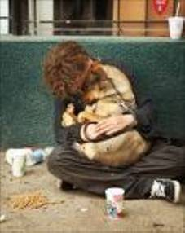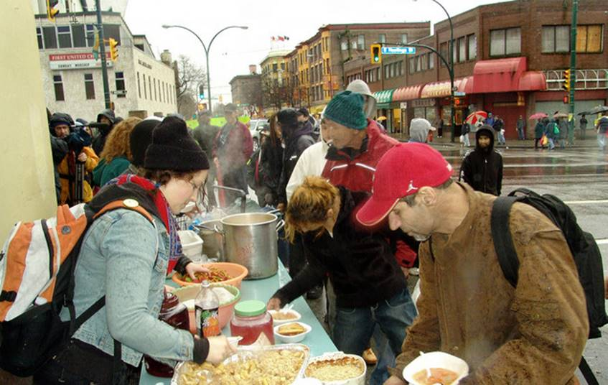
Reflection – November 22, 2020

Scripture: Matthew 25:31–46

While Advent does not start for another week, you wouldn’t know it: shops, and even homes, are increasingly being decked out with lights and decorations. People are eager and anxious for Christmas to come – a glimpse of hope, light, and joy in the midst of pandemic blues.
As we move into the Christmas season, there may be a desire to ignore those in need, to want people with Covid-19 to quietly disappear, to wish that homelessness and poverty, health issues and addiction would all just go away. They won’t. And as we move into the season, a classic passage from Matthew reminds us how Jesus hopes we will respond.
“I was hungry, thirsty, a stranger, naked, sick, and in prison – and you helped me.” Those words leap out of the Bible even today and remind us that when we see a person who has needs that are going unmet, we see Jesus Christ, calling us to action. This year, even more than other years, the call to smile at others, to reach out and touch their lives, and to make a difference for those who feel abandoned – that call is faced with new challenges. That does not mean we can ignore the call, but simply invites us to find new and innovative ways to bring the gospel of hope to those who need to hear it most.
_______________________________________________________________________________________________________________________________________________________

Worship with Summerland and Westbank United Churches
November 22, 2020 09:45 AM Vancouver

__ Join Zoom Meeting
https://us02web.zoom.us/j/83971543383
Meeting ID: 839 7154 3383
Passcode: 487991
Dial by your location
+1 778 907 2071 Canada
Meeting ID: 839 7154 3383
Passcode: 487991

Summerland United Church website also provides access to our weekly Zoom church service.
_____________________________________________________________________________________________________

November 22, 2020
A Sunday Service for Summerland and Westbank United Churches
Rev. Donald Schmidt - Presiding
Power Point: Judi Ritcey, LLWL – Summerland United
GATHERING TIME: 9:45 AM
TERRITORIAL ACKNOWLEDGEMENT
ANNOUNCEMENTS:
BELL RINGING: 10 AM

WORDS OF WELCOME: – Shelley Marks, Westbank United Church
A warm welcome to our friends from Summerland and Westbank United Churches who are with us today and to all those joining us from other locations. If there are any visitors joining us today from other congregations or other places, we would love to know your names. The host will now unmute everyone, and if you are comfortable, we invite visitors to introduce themselves.

MOMENT OF SILENCE TO VIEW THE CONGREGATION
LIGHTING THE CANDLE:
A TIME OF GATHERING:

WE SING TOGETHER: Make a Joyful Noise - VU 820

CALL TO WORSHIP
Be joyful and sing as you come to worship God.
Let the whole world shout praise to God!
We know that the one who made us is God. We are God’s people, and God is our shepherd.
Let the whole world shout praise to God!
Give thanks and praise to God as you gather to worship.
Let the whole world shout praise to God!
For God is good! God’s love and faithfulness last forever!
Let the whole world shout praise to God!

OPENING PRAYER: (from The Whole People of God)
I was hungry...and you said, “There just isn’t enough food to go around.”
Forgive us, God, when we ignore your Christ.
I was thirsty...and you kept polluting and poisoning the rivers and oceans.
Forgive us, God, when we ignore your Christ.
I was a stranger...and you kept your distance, afraid I would take your job.
Forgive us, God, when we ignore your Christ.
I was cold and scared...and you pulled your coat closer around yourself and walked away.
Forgive us, God, when we ignore your Christ.
I was sick...and you said, “You should take better care of yourself.”
Forgive us, God, when we ignore your Christ.
I was in jail...and you thought I should rot there forever.
Forgive us, God, when we ignore your Christ.
Jesus said, “Whatever you do to the least of my brothers and sisters, you do to me.”
Forgive us, God, when we ignore your Christ. (pause)
When we turn to God with honest and open hearts, God forgives us and lets us start again. So be assured that your sins are forgiven. Thanks be to God!

WE SING TOGETHER: Crown Him with Many Crowns (VU 211)

SCRIPTURE READING: Matthew 25:31–46 – Marilyn Hansen, Summerland United
REFLECTION:
WE SING TOGETHER: When I Needed a Neighbour (VU 600)

PRAYERS OF THE PEOPLE: Donald
THE LORD’S PRAYER: Jim Cotter Version,
OFFERING:
PRAYER OF DEDICATION:
WE SING TOGETHER: I See a New Heaven (VU 713)
BLESSING

BREAK INTO CHAT ROOMS
________________________________________________________________________________________________________________________________________________________

MATTHEW:25: 31-46, Common English Bible

Judgment of the nations

31 “Now when the Human One[a] comes in his majesty and all his angels are with him, he will sit on his majestic throne. 32 All the nations will be gathered in front of him. He will separate them from each other, just as a shepherd separates the sheep from the goats. 33 He will put the sheep on his right side. But the goats he will put on his left.

34 “Then the king will say to those on his right, ‘Come, you who will receive good things from my Father. Inherit the kingdom that was prepared for you before the world began. 35 I was hungry and you gave me food to eat. I was thirsty and you gave me a drink. I was a stranger and you welcomed me. 36 I was naked and you gave me clothes to wear. I was sick and you took care of me. I was in prison and you visited me.’

37 “Then those who are righteous will reply to him, ‘Lord, when did we see you hungry and feed you, or thirsty and give you a drink? 38 When did we see you as a stranger and welcome you, or naked and give you clothes to wear? 39 When did we see you sick or in prison and visit you?’

40 “Then the king will reply to them, ‘I assure you that when you have done it for one of the least of these brothers and sisters of mine, you have done it for me.’

41 “Then he will say to those on his left, ‘Get away from me, you who will receive terrible things. Go into the unending fire that has been prepared for the devil and his angels. 42 I was hungry and you didn’t give me food to eat. I was thirsty and you didn’t give me anything to drink. 43 I was a stranger and you didn’t welcome me. I was naked and you didn’t give me clothes to wear. I was sick and in prison, and you didn’t visit me.’

44 “Then they will reply, ‘Lord, when did we see you hungry or thirsty or a stranger or naked or sick or in prison and didn’t do anything to help you?’ 45 Then he will answer, ‘I assure you that when you haven’t done it for one of the least of these, you haven’t done it for me.’ 46 And they will go away into eternal punishment. But the righteous ones will go into eternal life.”

