Sunday January 10, 2021
Summerland United Church 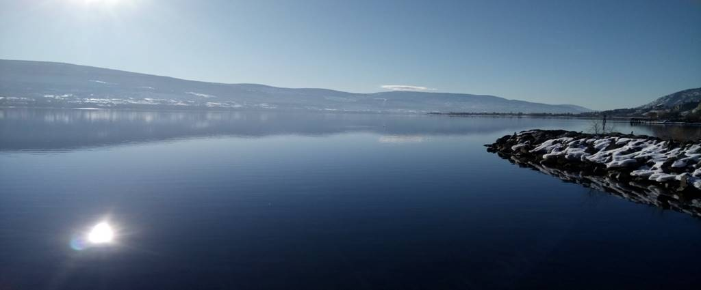
Sign in for Zoom Service @ 9:45
You are Welcome
There’s a woman who does predictions by squeezing a piece of asparagus against a wall. I’ve never seen her do it, so it could be quite interesting and edifying. But I doubt it. It’s just that, well, I’m not a big fan of predicting the future. I would sometimes send my horoscope to a friend in Australia who is the same sign as me, and ask her if it came true – that’s about it.
The asparagus reader has predicted that there will be another split in the royal family (not necessarily a surprise); that there will be changes to the way professional athletes are paid (considering most seasons are disrupted and shortened and mutated, that’s not a surprise either); and interestingly that the most popular name for boys this year will be Gus (really?).
The one that did intrigue me, though, was her prediction that people will become kinder and more tolerant. Gee I hope so.
If we thought before we spoke – or better yet, if we thought (and reread) before we hit the “send” button on emails and posts – the world would be a better place.
If we would smile more, not assuming that anyone who smiles is about to ask you for money.
If we tried to find ways to help others, and then acted on them.
If we committed ourselves to seeking, and demanding, justice, even though it’s seldom very popular with those in power.
Think of the possibilities. Happy new year.
______________________________________________________________________________
A Sunday Service for Summerland and Westbank United Churches
Rev. Donald Schmidt-Presiding
Power Point Judi Ritchey, LLWL-Summerland United

GATHERING TIME 9:45 AM

TERRITORIAL ACKNOWLEDGEMENT Donald

ANNOUNCEMENTS Donald

BELL RINGING 10 AM

WORDS OF WELCOME: Kathryn McLaughlin, Summerland United
A warm welcome to our friends from Summerland and Westbank United Churches who are with us today and to all those joining us from other locations. If there are any visitors today from other congregations or other places, we welcome you and thank you for joining us this morning. If you are comfortable, please unmute yourself and tell us where or what congregation you are from. Please remember to re-mute yourself.

MOMENT OF SILENCE TO VIEW THE CONGREGATION – Donald

LIGHTING OF OUR SUNDAY CANDLES

WE SING TOGETHER: Behold, Behold I Make All Things New (MV 115)

CALL TO WORSHIP (from Study and Worship – the Birth of Jesus)
From far distances, the magi came
seeking the new ruler God had sent.
When they confronted roadblocks, God helped them find new ways through.
May we, too, find ways past the roadblocks the world sometimes puts in our way.
Come, friends, and let us worship God.

OPENING PRAYER: (from Study and Worship – the Birth of Jesus)
Loving God, you sent a star to offer hope and new life to the magi. When they encountered difficulties on their journey and their faith may have faltered, still you remained with them. When they encountered the Christ child they found their lives changed and chose to venture back into life in a new way. So may we dare to respond to this story by moving into this new year on a new path, and by opening ourselves to the wondrous surprises you offer. Amen.
WE SING TOGETHER: Will You Come and See the Light (VU 96)

SCRIPTURE READING: Matthew 2:1–12 - Eric Davis– Westbank United
WE SING TOGETHER: I Have Called You by Your Name (VU 161)

REFLECTION: Donald
WE SING TOGETHER: A Light Is Gleaming (VU 82)

PRAYERS OF THE PEOPLE: Donald
THE LORD’S PRAYER: Donald

OFFERING: Donald PRAYER OF DEDICATION: Donald
God of restoration and remembrance take our gifts and mould them, craft them, and shape them into those things that bring your hope to all the world. Amen. 2

HOLY COMMUNION
May God be with you.
And also, with you.
Lift up your hearts.
We lift them to God.
Let us give thanks to our Creator God.
It is right to give God thanks and praise.

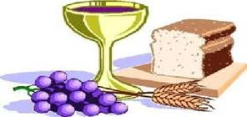
The prayer continues

Holy, holy, holy,
God of power and might.
Heaven and earth are full of your glory.
Hosanna in the highest.
Blessed is the one
who comes in the name of our God.
Hosanna in the highest.

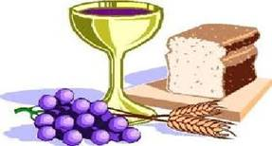

The prayer continues

WE SING TOGETHER: I Am the Light of the World (VU 87)
BLESSING Donald
BREAK INTO CHAT ROOMS
______________________________________________________________________________

Worship with Summerland and Westbank United Churches
January 10, 2021 09:45 AM Vancouver

__ Join Zoom Meeting
https://us02web.zoom.us/j/83971543383
Meeting ID: 839 7154 3383
Passcode: 487991
Dial by your location
+1 778 907 2071 Canada
Meeting ID: 839 7154 3383
Passcode: 487991

Summerland United Church website also provides access to our weekly Zoom church service.
_______________________________________________________________________________

Matthew 2:1-12 - Common English Bible

Coming of the magi
2 After Jesus was born in Bethlehem in the territory of Judea during the rule of King Herod, magi came from the east to Jerusalem. 2 They asked, “Where is the newborn king of the Jews? We’ve seen his star in the east, and we’ve come to honor him.”

3 When King Herod heard this, he was troubled, and everyone in Jerusalem was troubled with him. 4 He gathered all the chief priests and the legal experts and asked them where the Christ was to be born. 5 They said, “In Bethlehem of Judea, for this is what the prophet wrote:

6 You, Bethlehem, land of Judah, by no means are you least among the rulers of Judah, because from you will come one who governs, who will shepherd my people Israel.”[a]

7 Then Herod secretly called for the magi and found out from them the time when the star had first appeared. 8 He sent them to Bethlehem, saying, “Go and search carefully for the child. When you’ve found him, report to me so that I too may go and honor him.” 9 When they heard the king, they went; and look, the star they had seen in the east went ahead of them until it stood over the place where the child was. 10 When they saw the star, they were filled with joy. 11 They entered the house and saw the child with Mary his mother. Falling to their knees, they honored him. Then they opened their treasure chests and presented him with gifts of gold, frankincense, and myrrh. 12 Because they were warned in a dream not to return to Herod, they went back to their own country by another route.

